1. Homepage (For members)
2. Login Page and registration page

* User will have to register first and then he/she will be prompted to login once the registration is successful.

1. Gallery

* Members will be able to view all the photographs of the events which took place in the society

1. Notices

* All the important notices will be shown in this section.

1. View Maintenance History

* Member can view his/her own maintenance history; about how much payments he/she has paid and can view pending maintenance records which he/she has to pay.

1. Pay Current Month Maintenance

* This is not a separate tab. Once the user sees any pending maintenance record the user will have an option to pay the same.

1. View Minutes of meetings

* If any member was unable to attend meeting, then the admin will be posting the minutes of the meeting which the user can view in this section.

1. Raise Complaints

* User can lodge a complaint if he/she faces any issue.

1. My Profile

* User can view his profile which will be added by admin. Only certain fields will be editable. (Else everything will be read-only).
  1. Update photo
  2. Update password
  3. Update Mobile number
  4. Add Information about the tenants (if any)
  5. All other read – only details will be-> Flat No, Name, Id proof No, Parking details…...

1. Permissions

* User can ask for any permissions and post it to send it to the admin. (It will be visible to the admin and the logged in member only).

1. Login
2. Admin
3. Member
4. Security Guard

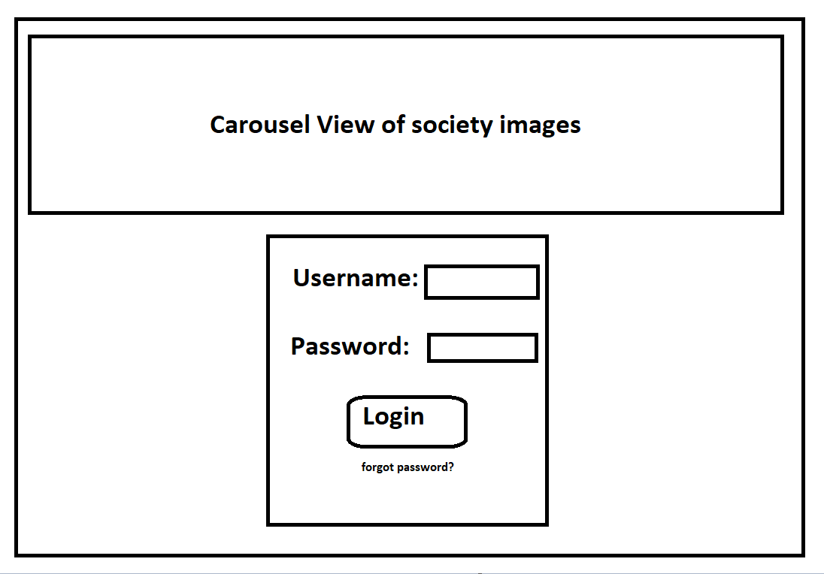

Admin Dashboard

Tabs

1. Add security guard’s data…..

* Admin will be adding the security guard’s data and once the data is registered the security guard will be given a login and password (through email) to log in to the application.

1. View member’s data
2. View Maintenance of the individual member
3. Generate E-Receipt and mail it to the respective member who has paid the maintenance.
4. And the ones who haven’t paid the maintenance, a warning email will be sent by the admin to the members.
5. Add festivals and other Notices (pdf?)

* All the important notices about the society and notices related to the festivals being conducted in the society will be posted by the admin and the user will be able to see the once on their wall after logging.

1. Add meeting link / meeting information and send it to the member’s email id or in the notice tab.(optional)
2. Post meeting minutes

* The admin will be posting the minutes of the meeting after every meeting so that members can view it.

1. Post Festival Photos

* A gallery section will be maintained where in all the photos will be posted by the admin which the user can see.

1. View Overall Maintenance History of all the flat owners. (optional)
2. Manage/Allot parking area to member’s (??)

* Admin will be allocating the parking area number to the society member.

1. View and grant permissions for event Bookings on terrace / Renovation of the flat

* All the members who have asked for permissions; the admin can view and grant the permission. Once the permission is granted a mail will be sent to the respective member about the same.

1. View tenant Details(optional)
2. View Visiting Member’s Details
3. View Complaints

* Admin can view the complaints lodged by the member and can send a comment to the member about the same.

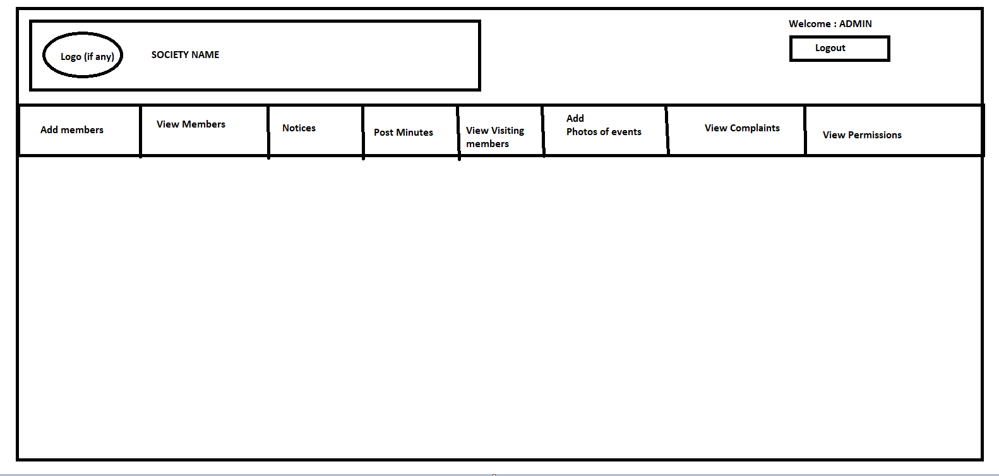

Security Guard Dashboard

1. Login

* Login ID will be given to the guard through email and the guard has to log in to the site using the same login ID and password.

1. Add Visitors Details
2. Visitor’s Name

* For security purposes all the details which the guard used to write in a book will be writing on the website now, which can be viewed by the admin.

1. Visitor’s Id proof(optional)

* Any delivery boy will be asked to submit his identity proof.

1. Visiting to which flat

* The information about the visitor visiting to which flat number and wing will be entered by the guard.